Muhammad Iqbal Raamadhan
Class TI/2I
Number 18
3.1 Experiment Activity 1 In this activity, we would demonstrate about how creating class, creating object, then accessing method in the class. 1. Open NetBeans, create project BikeDemo. 2. Create class Sepeda. Right click on the package BikeDemo – New – Java Class. 3. Type this code in class Bike.
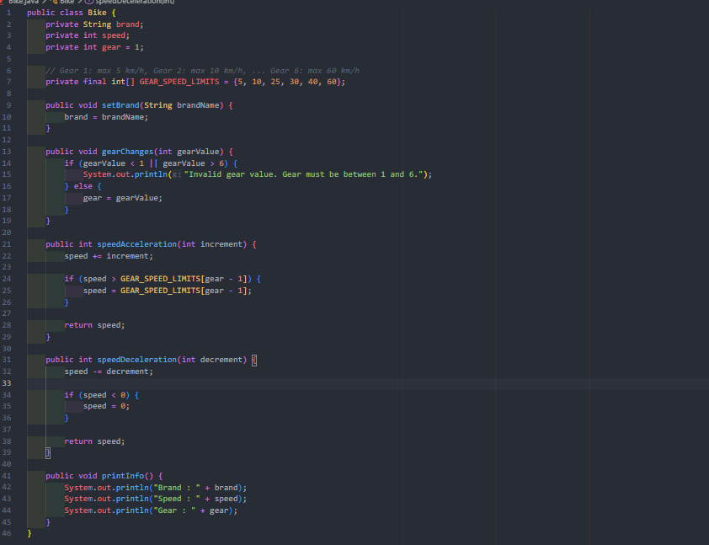
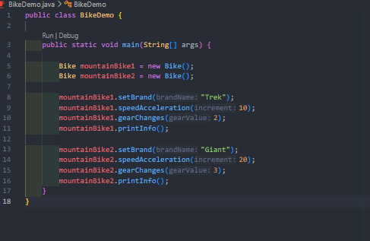
Result

3.2 Experiment 2 In this activity, we would demonstrate inheritance. We perform this inheritance technique by creating class RoadBike which is inherited from class Bike. Basically, class RoadBike I similar with class Bike but it has tire width state. By doing this, we may not creating class RoadBike from the scratch, it just inherits from class Bike to class RoadBike. More detail explanation about inheritance will be discussed in the next module. 1. Still in the project BikeDemo. Create a class named RoadBike. 2. Add a code extends Bike at the class RoadBike declaration. This extends points that class RoadBike inherits class Bike.
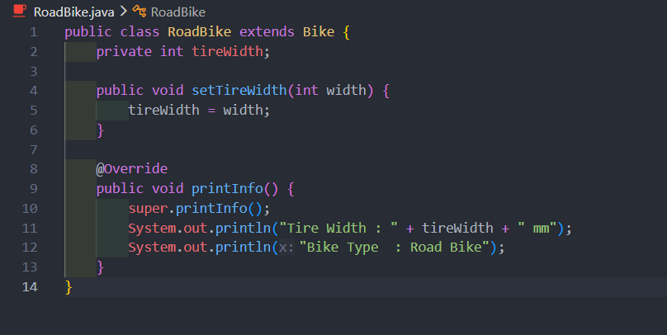
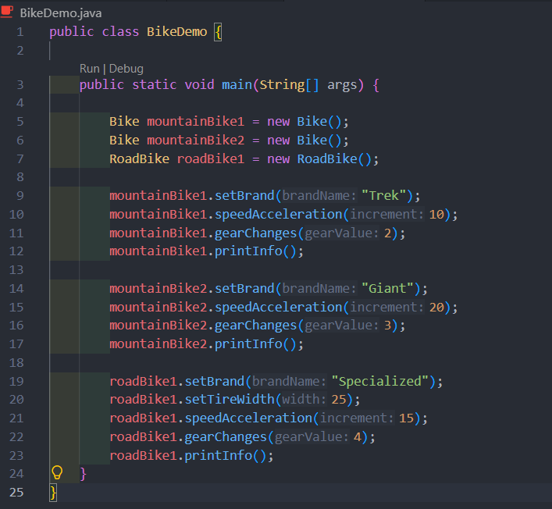
Result
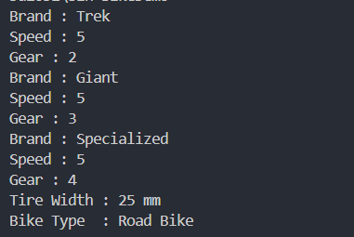

A. Question Test
1. Difference Between Object and Class
- Class: A blueprint, template, or abstract design that defines the structure (attributes) and behavior (methods) of a group of objects. A class does not occupy memory space for actual data.
- Object: A real instance created from a Class that resides in computer memory and holds specific data/values for its attributes.
2. Reason Why Gear and Brand Are Attributes for a Bike Object
- Brand and Gear represent properties, states, or physical characteristics of a bicycle. Since they store data rather than performing actions or behaviors, they are classified as attributes.
3. Advantage of OOP Over Procedural Programming
- Code Reusability & Maintainability: Through concepts like Inheritance and Encapsulation, existing code can be reused and extended without writing it from scratch, making large-scale software development and maintenance significantly easier.
4. Is "public String name, address;" Allowed?
- Yes, it is allowed. In Java syntax, multiple variables sharing the same data type (String) and access modifier (public) can be declared on a single line separated by commas (,).
5. Reason Why Brand, Speed, and Gear Are Not Written Again in RoadBike Class
- The RoadBike class applies Inheritance by extending its parent class (e.g., the Bike class). Consequently, RoadBike automatically inherits all non-private attributes from the parent class without needing to redefine them.

B. Practical Assignment
- a. Take 4 photographs of objects around you, 2 objects must be implementation of inheritance concept, example: refrigerator, chair, living room table, desk! As we know that living room table and desk are inherited by table class.
Laptop

Smarthphone

Wall clock

Water bottle


- b. Observe those objects to define the attribute and method!
Laptop: Uses ram and processor as its own attributes (along with inherited brand and powerConsumption). Its methods are openApp(), code(), and displayInfo().
Smartphone: Uses batteryCapacity and cameraCount as its attributes (plus inherited brand and powerConsumption). Its methods are takePhoto(), makeCall(), and displayInfo().
Wall Clock: Uses color and shape as its attributes. Its methods are tick(), changeBattery(), and displayInfo().
Water Bottle: Uses capacity and material as its attributes. Its methods are fillWater(), drink(), and displayInfo().

- c. Convert those objects into four classes in Java programming!
These 4 observed objects are created as separate Java classes named Laptop, Smartphone, WallClock, and WaterBottle.
- d. Add one additional class as a class which inherits its attribute and method to living room table class and desk class!
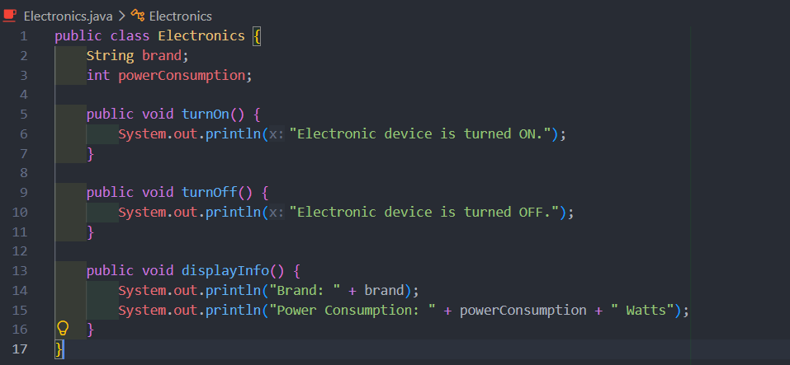
- e. Add two attributes for each class!
- Electronics: brand, powerConsumption
- Laptop: ram, processor
- Smartphone: batteryCapacity, cameraCount
- WallClock: color, shape
- WaterBottle: capacity, material

- f. Add three methods for each class including a method for showing the information!
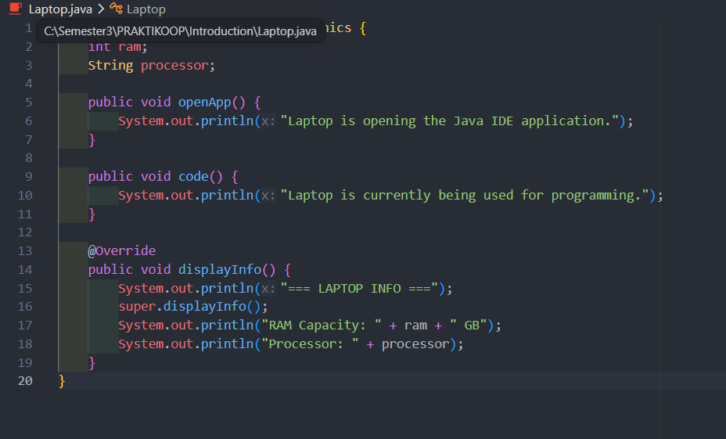
- g. Add one class named Demo for main class!
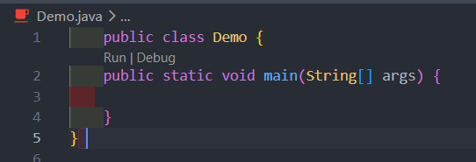

- h. Instance an object for each class!
- 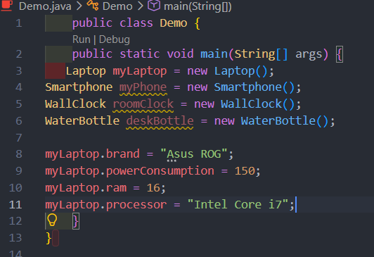
- i. Apply each method for each object in main class!
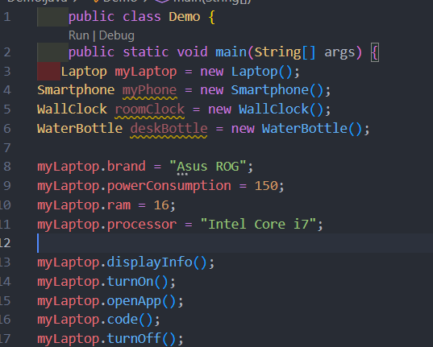
- j. The example which is mentioned in point 1.a should not be included in your task!
The forbidden examples (refrigerator, chair, living room table, and desk) are excluded. The objects used in this assignment are Laptop, Smartphone, Wall Clock, and Water Bottle.
RESULT
Link Github
https://github.com/ZX0ldy/Semester3/tree/main/PRAKTIKOOP/Introduction
